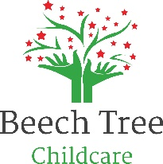

Yearly Rate Review and Pattern of Delivery of Funded hours (FE hours)

From 1st April 2024:
Funded hours (2,3- & 4-year-old funding) can only be used from 10.00am-3.30pm Monday to Friday.
Hourly rate for all children - £7.00 per hour
Hourly rate – sibling discount - £5.50 per hour
A sibling discount will not be applied if one or more of your children are accessing FE hours.

Children accessing new 2-year-old funding and new 3- & 4-year-old funding will receive their funded hours from 15th April 2024 as per WSCC rules.

We will continue to offer 3 free funded spaces which have no restrictions on times/days, which will be reviewed termly. These spaces are limited to children who must meet the following criteria:
Looked After Children, Adopted Children, Foster Children, Refugees, Children who are subject to a social services plan.

Meals
Paying for our meals at Beech Tree Childcare is optional. If subscribing to our meals supplied by Little Tum’s, the charges are £3.50 per meal. This will be reviewed if Little Tum’s increase their prices. At Beech Tree Childcare we offer the option for families to provide a packed meal as part of your funded place.
Can the funded hours be split between more than one childcare provider (including those in another county)?

Yes, you can split the hours between a maximum of two childcare sites (per day) that are registered to receive the funding.
A notice period of 4 weeks in writing is required if you wish to reduce funded hours or transfer them to another setting.

